CampusSync Project Report

1. Master App Flow (Overall Architecture)
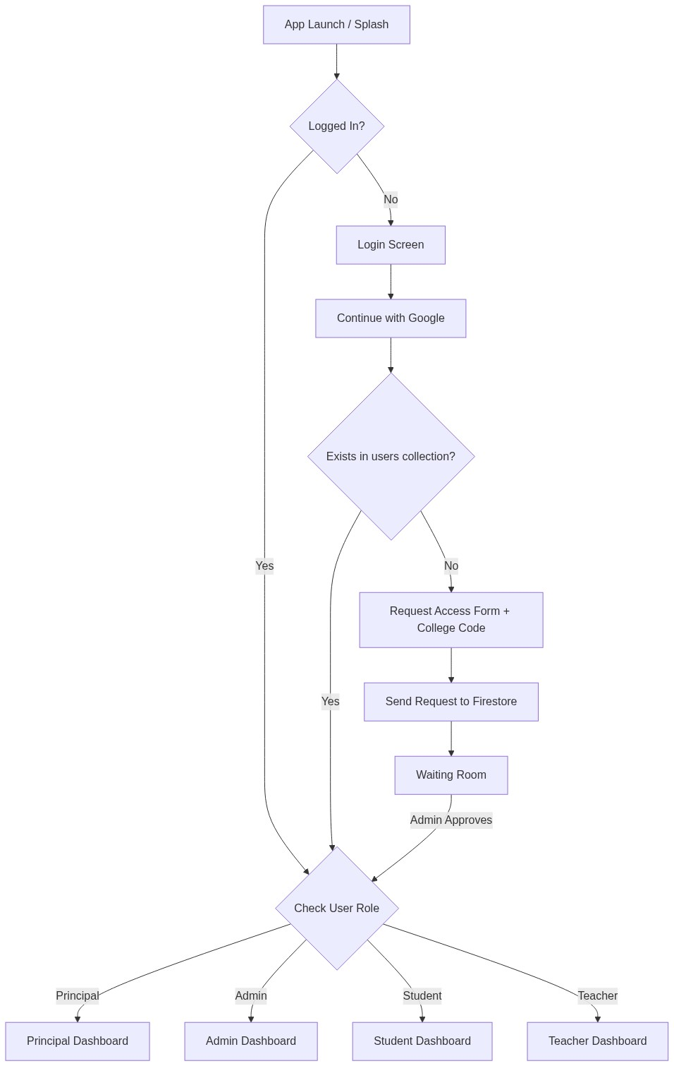

Report & Explanation
This flow demonstrates the bird's-eye view of CampusSync. It highlights the multi-tenancy entry point. When a new user logs in via Google, the system checks if they exist in the database. If not, they are directed to the Request Access Form where they must provide a unique College Code. They are then placed in a waiting room until their respective college Admin approves them. Once approved, they are routed to their role-specific dashboard.

2. Principal & Admin Flow (Management & Verification)
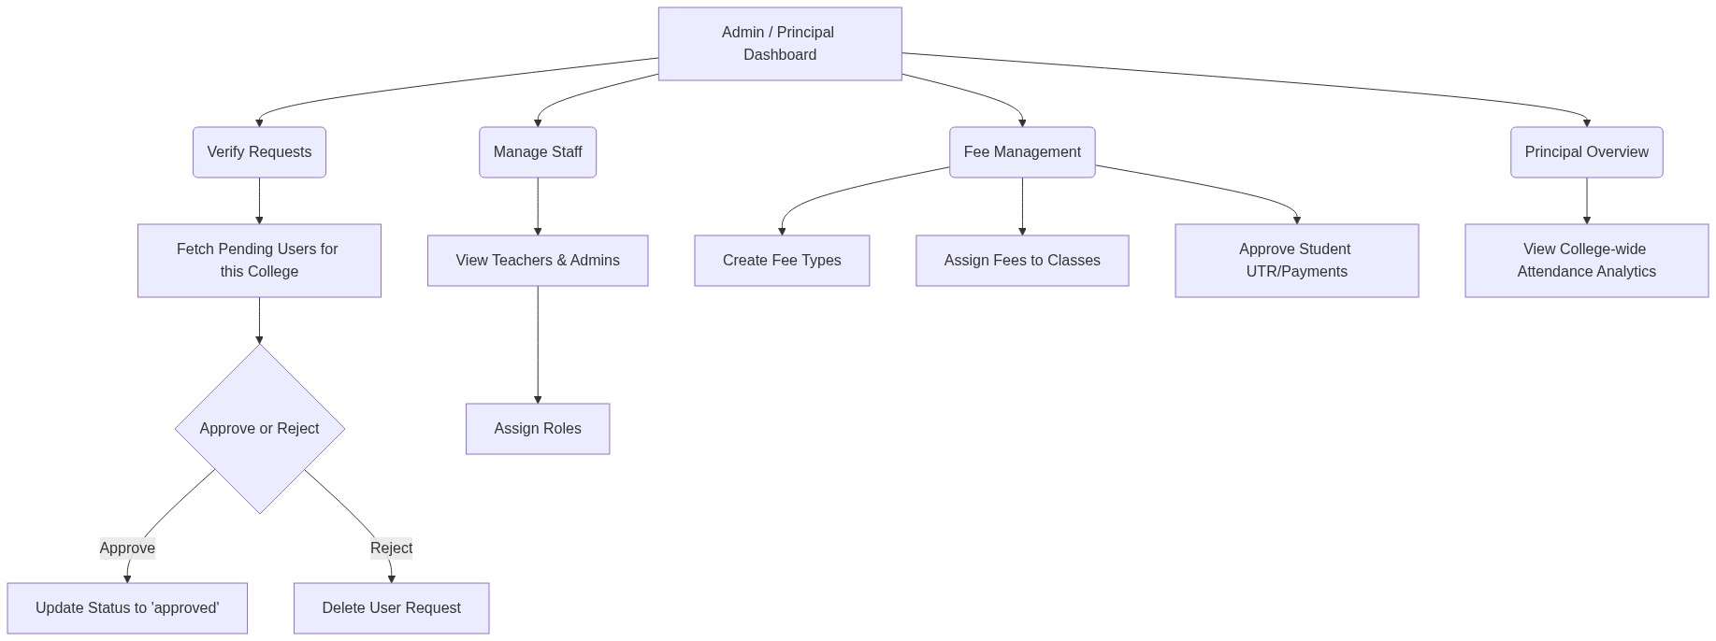

Report & Explanation
The Admin/Principal workflow handles high-level management. The most critical aspect is Verify Requests, where the system queries only those pending users whose collegeId matches the Admin's. The Admin can approve (updating the user's status to 'approved' in Firestore) or reject (deleting the user from the database). Additionally, Admins can create fee structures, assign them to specific classes, and verify UTR numbers for payments made by students.

3. Teacher Flow (Attendance & Academics)
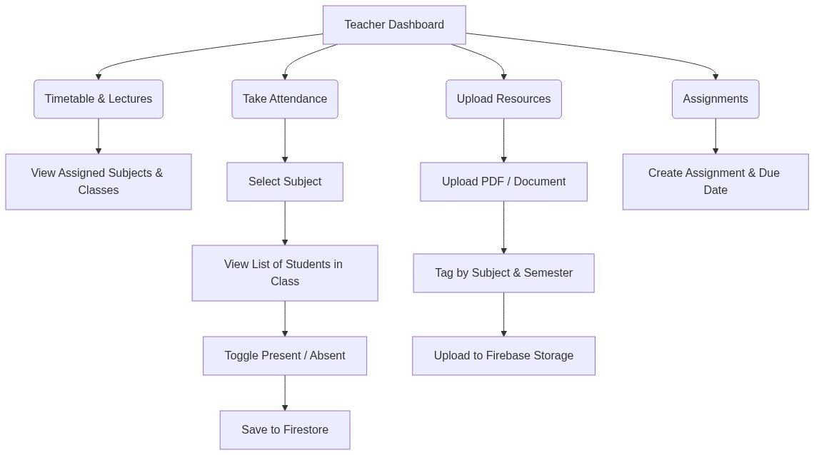

Report & Explanation
Teachers are responsible for daily academic operations. They can select their assigned subjects and classes to Take Attendance (instantly saved and synced to Firestore). They can also Upload Resources (like notes and PDFs), tagging them properly by subject and semester for students to easily locate them in the cloud. Finally, they can create assignments and track which students have completed them.

4. Student Flow (Learning & Fees)
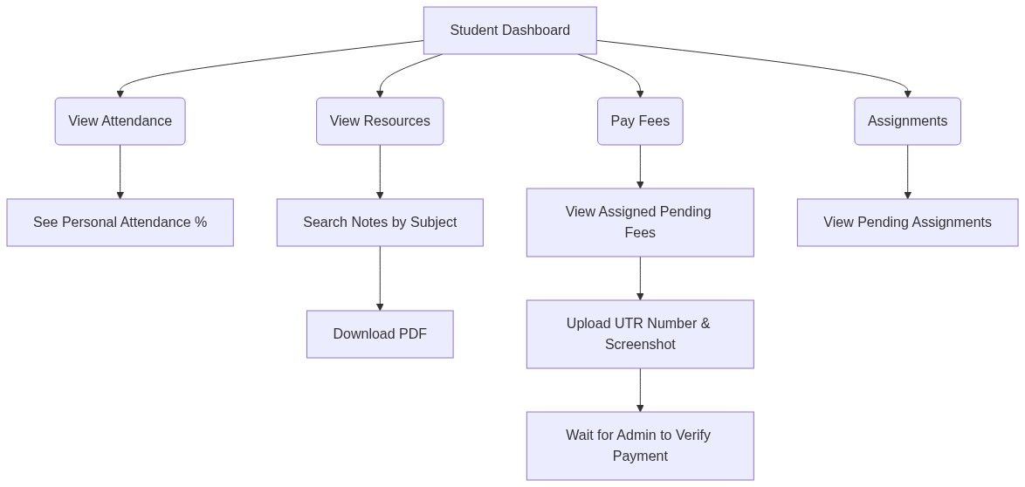

Report & Explanation
The Student dashboard provides read-only access to academic data and read-write access to fee payments. Students can monitor their real-time attendance statistics updated by teachers. They can search the digital library to download PDF notes uploaded by their instructors. For administration, students can view their pending fees, upload UPI payment screenshots along with the UTR number, and wait for the Admin to verify and clear their dues.

5. Database Architecture (Firestore NoSQL Map)
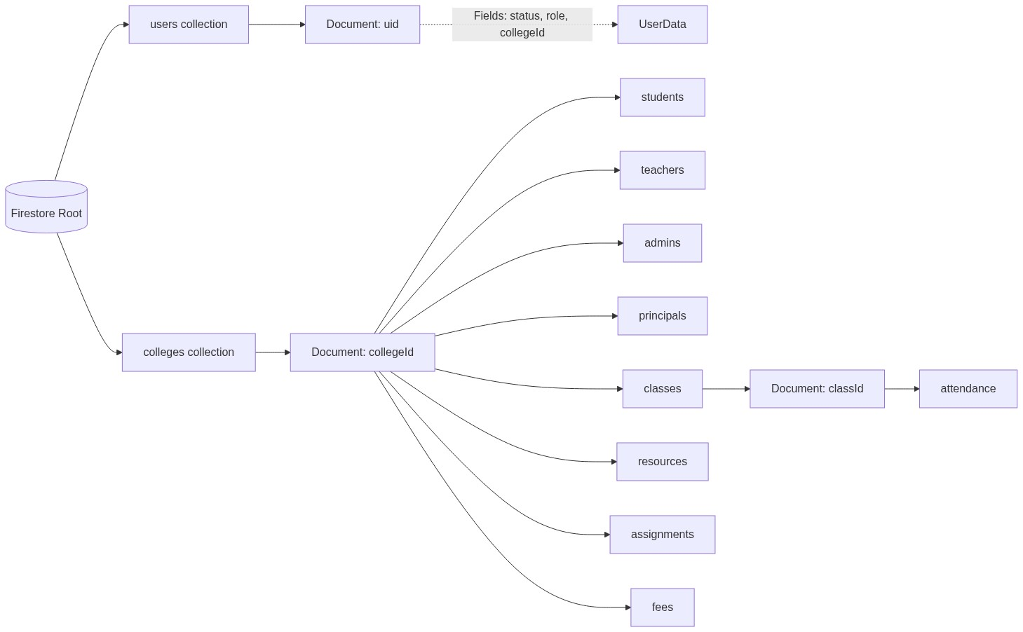

Report & Explanation
The Firebase Firestore database follows a multi-tenant hierarchy. The root 'users' collection tracks global identities, their active 'status', and their associated 'collegeId'. All primary data is nested under the 'colleges' collection. Within a specific college document, data is categorized into role-specific collections (students, teachers, admins, principals) and operational collections (classes, resources, assignments, fees). This ensures that data from one college is completely isolated from another.

6. Core Logic & Data Saving Mechanisms
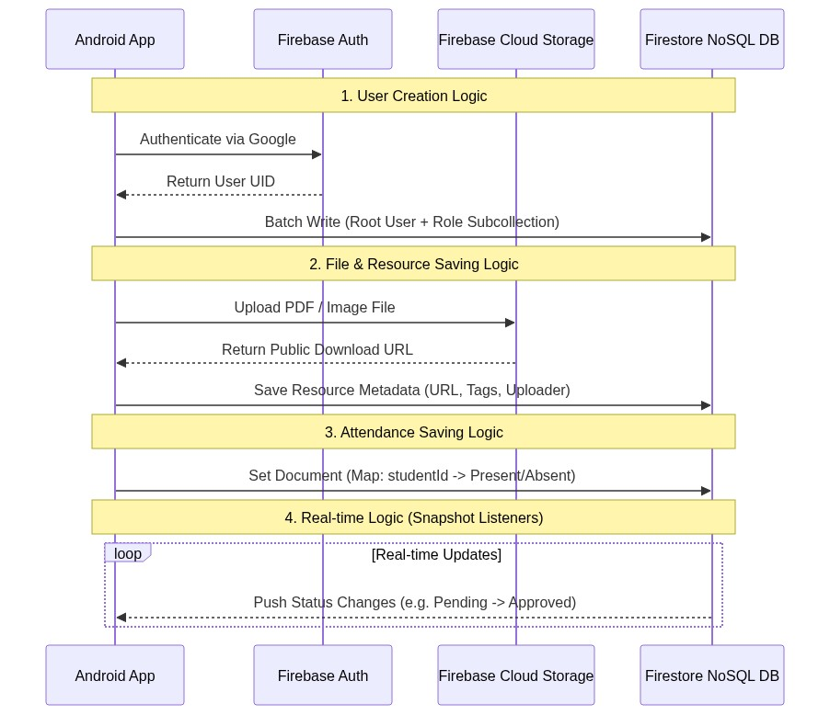

Report & Explanation
This section outlines the internal business logic and how data is processed and saved in the cloud:
1. Authentication & Batch Writing: When a user signs in, the app receives a UID from Firebase Auth. To ensure data consistency, the app uses 'Firestore Batches' to simultaneously create the user in the root 'users' collection and in their specific role subcollection. If either fails, the entire operation is rolled back.
2. File Storage Logic: When a teacher uploads a resource or a student uploads a payment screenshot, the physical file is uploaded to Firebase Cloud Storage. The app waits for a secure 'Download URL' from Storage, and then saves that URL alongside metadata (tags, uploader name, timestamps) into the Firestore database.
3. Attendance Logic: Instead of creating a separate document for every student per class, attendance is efficiently saved as a HashMap (key-value pair) within a single document for that lecture (e.g., studentId -> 'present' / 'absent').
4. Real-time Sync Logic: The app heavily utilizes 'Snapshot Listeners'. Instead of manually refreshing the app, any changes in the database (like an Admin approving a student's pending request) are instantly pushed to the Android client, triggering automatic UI updates and navigation.

